Wander Meijer, Executive Director Kadoorie Farm & Botanic Garden

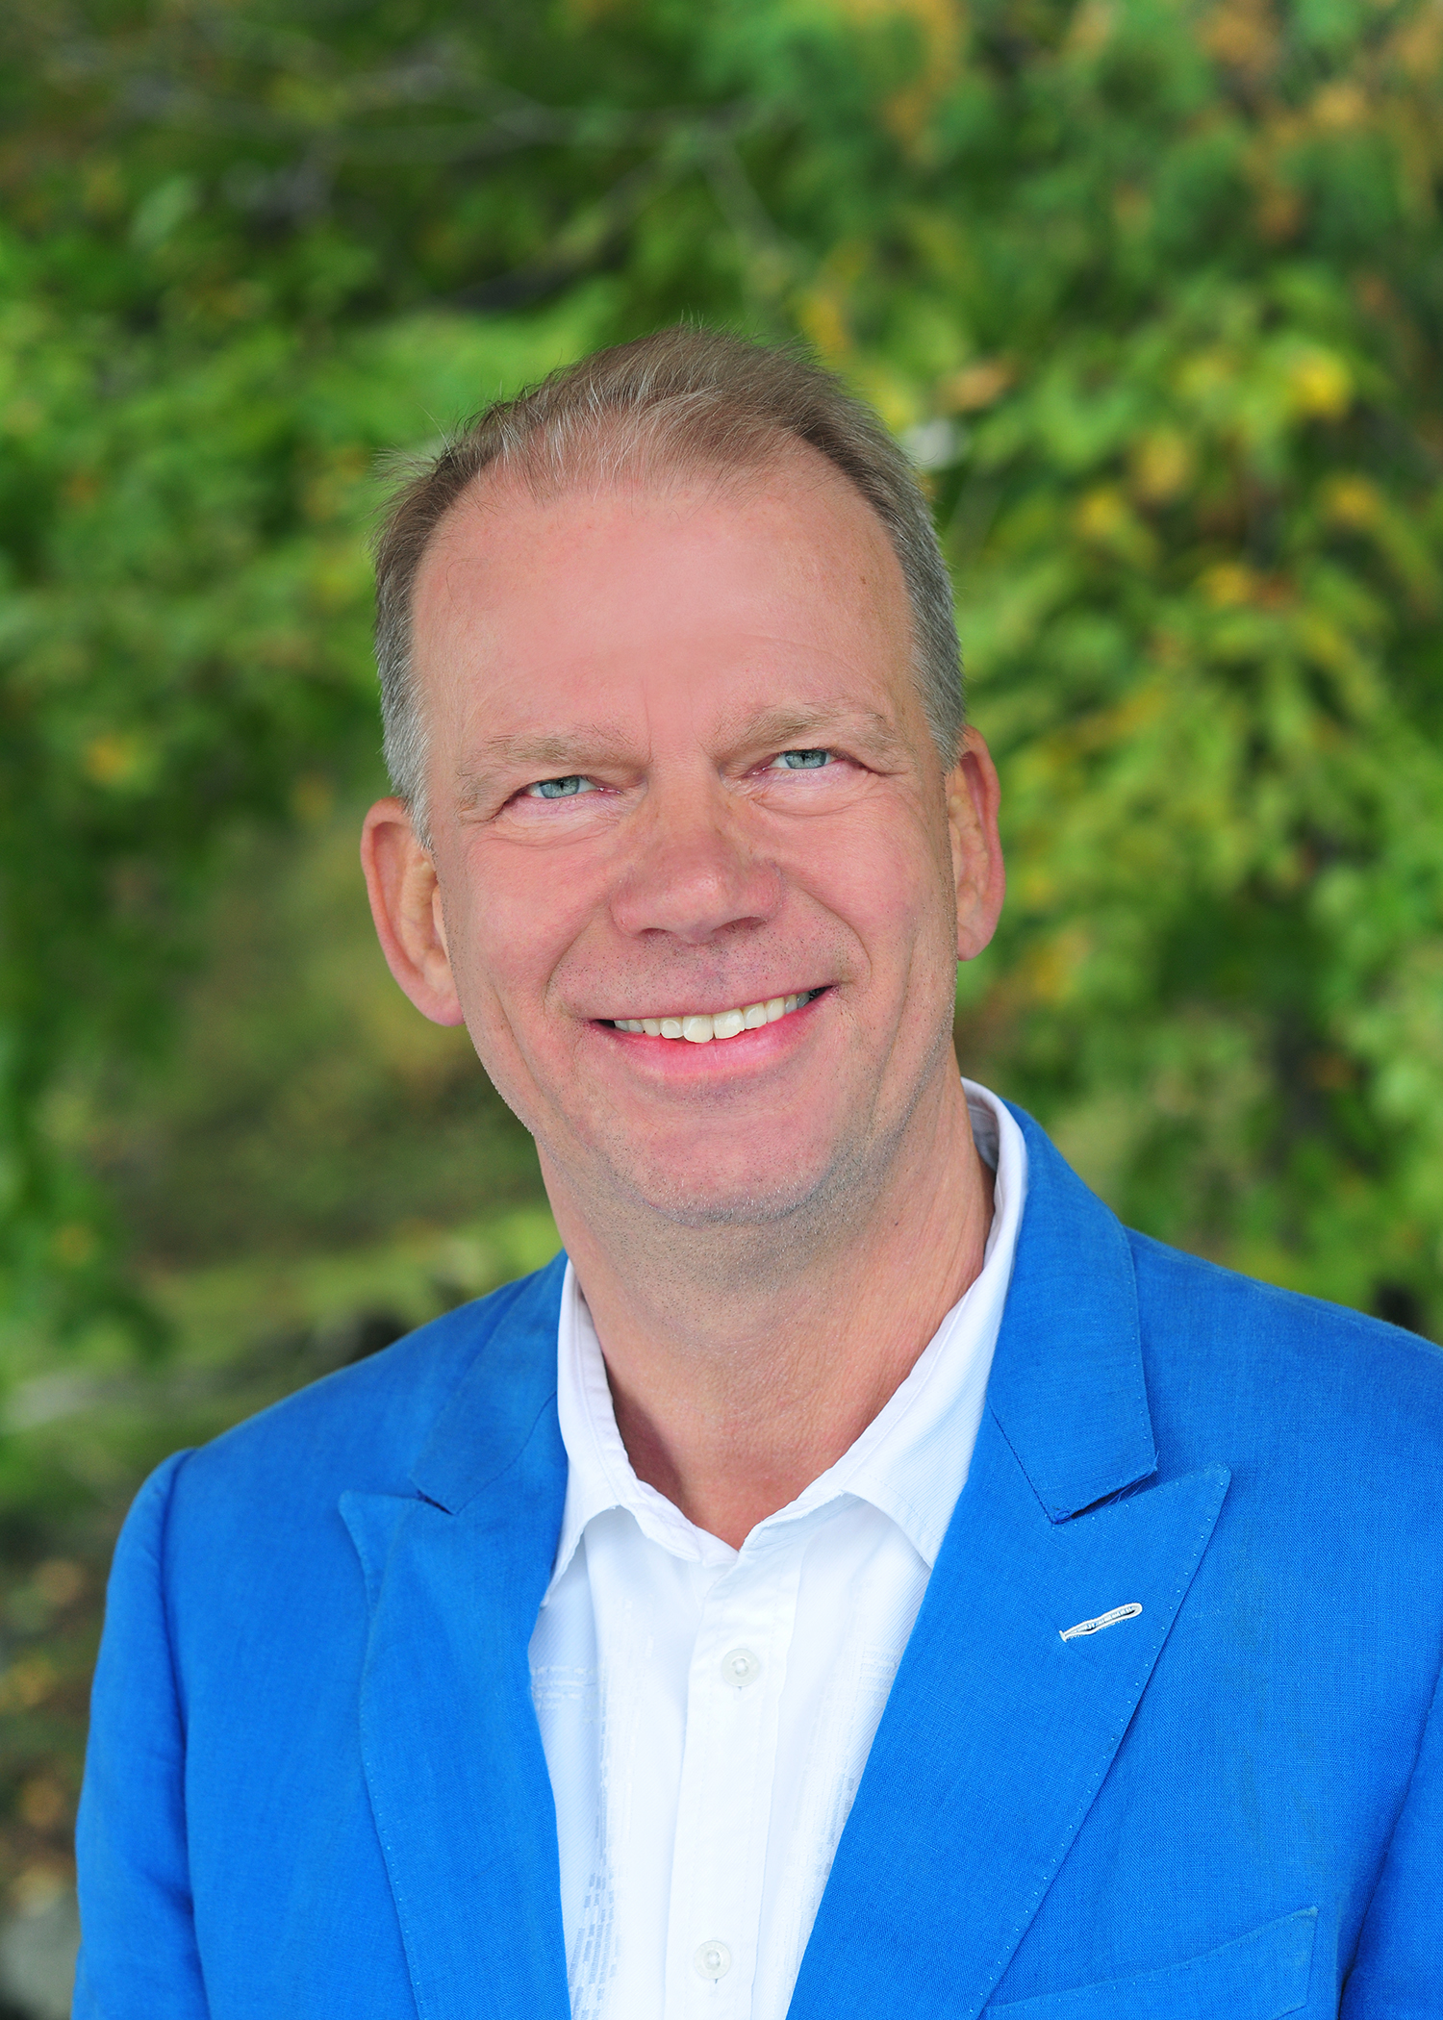
Wander is a senior executive with 25+ years management experience in businesses and NGOs in Europe, Asia Pacific and Latin America. He started his career in the Netherlands, and moved after 6 years to Asia, where he worked for TNS, a global research firm, as Managing Director for Hong Kong, China, the Philippines and Singapore, and then was four years CEO for Latin America.

From 2015 to 2021, Wander was Director Asia Pacific for GlobeScan, a global environmental consultancy.

Since November 2021, Wander leads Kadoorie Farm and Botanic Garden as Executive Director, where he and his team of 250 staff work on biodiversity, wildlife rehabilitation, organic farming, reforestation, sustainable living and holistic education with the vision to harmonize our (human) relationship with nature.

Furthermore, Wander is business advisor of and impact investor in social enterprises in Africa and the Netherlands, related to poverty alleviation and agricultural transition.

Wander has a master’s degree Development Geography and Economics with as main subject: ‘Why are some countries rich and others poor?’ and what can we do about it! Specifically, how can we change our current economic model and human behavior to better live within the ecological boundaries of the earth.

